MerchantEnrolmentAPI - All the business logic is written in this solution.

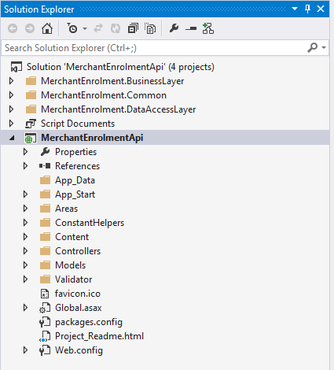

Once the application is run it will open in browser with following url.

http://localhost:1109/

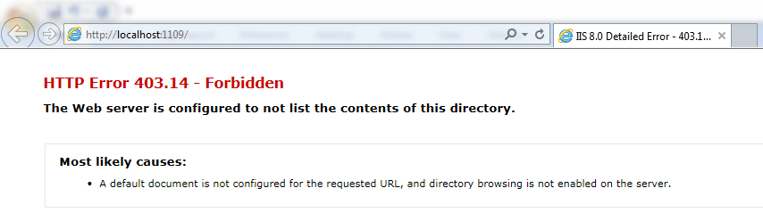

To test API services use swagger url. Navigate to below url we will get all the API's listed in browser. we can use those api and send the required parameters to test the API code.

http://localhost:1109/Swagger/Ui/index#/MerchantEnrolment

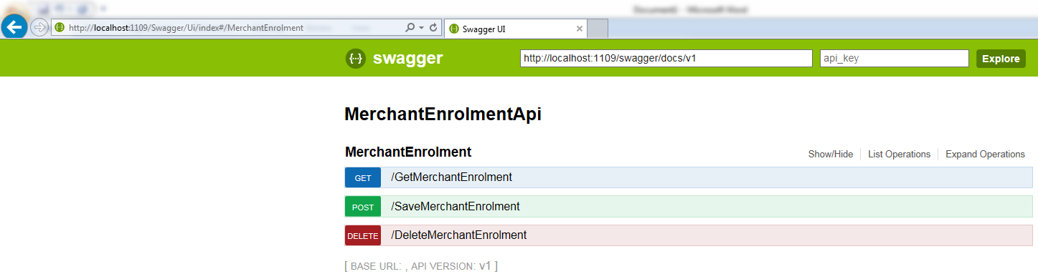

MerchantEnrolmentPortal - In this solution we written all the UI logic to create the enrolment.

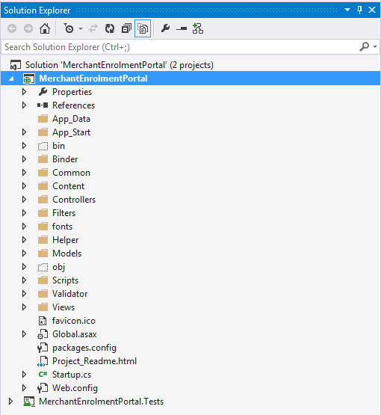

Update the API url in case it's different from the Portal solution config file.

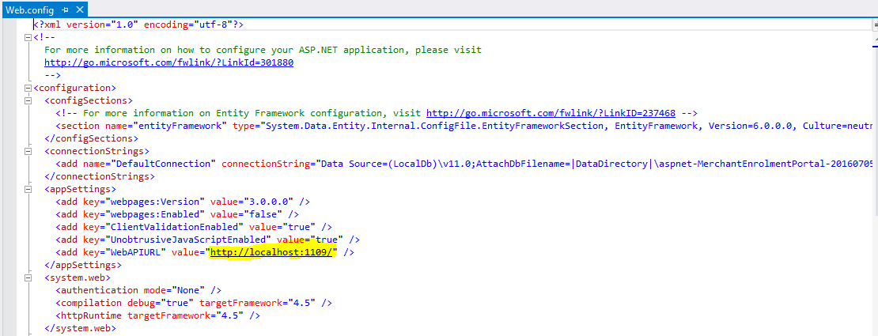

Run the solution we will see the dashboard with existing records created in repository classes.

http://localhost:65474/

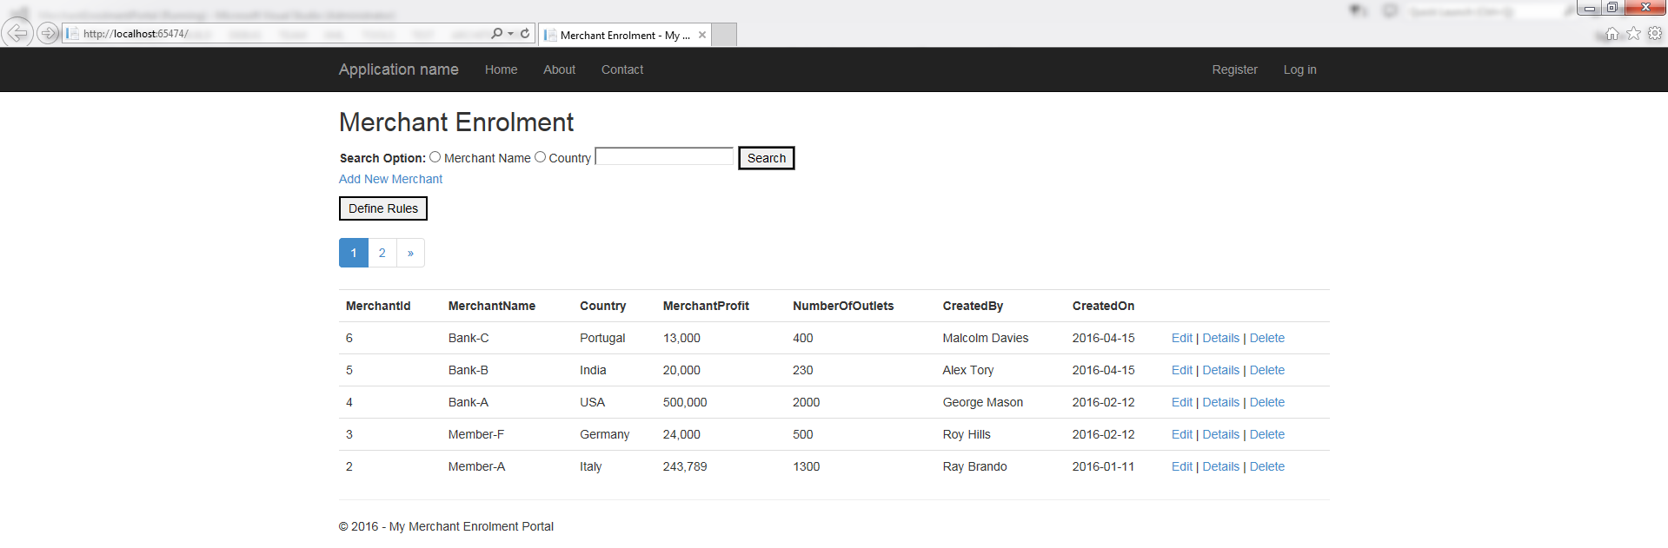

We can search dashboard either with Merchant name or Country name. (On key event search is not implemented, with actual key word search will work)

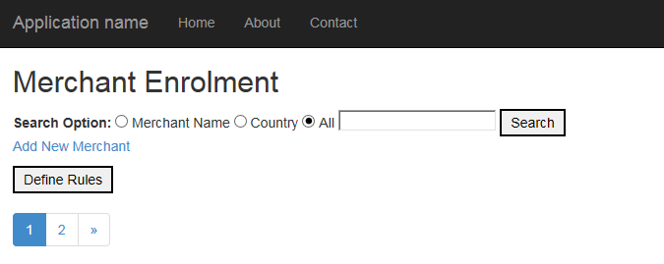

Click on link Add New Merchant to create New merchant

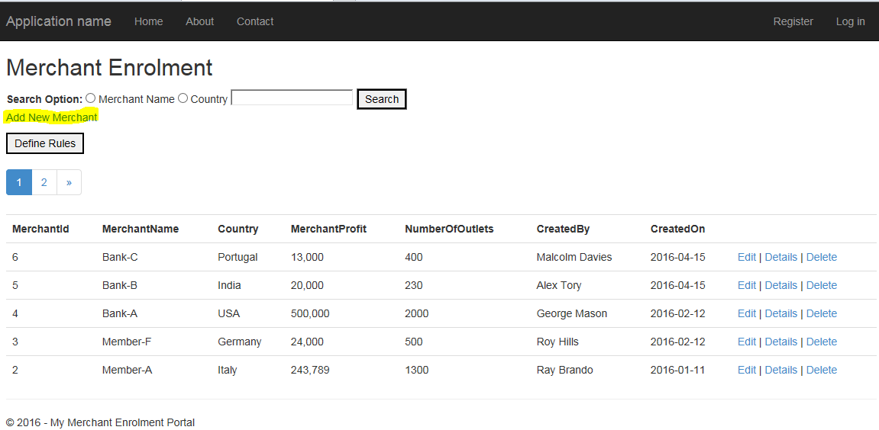

Below screen will be visible where we can create New Merchant

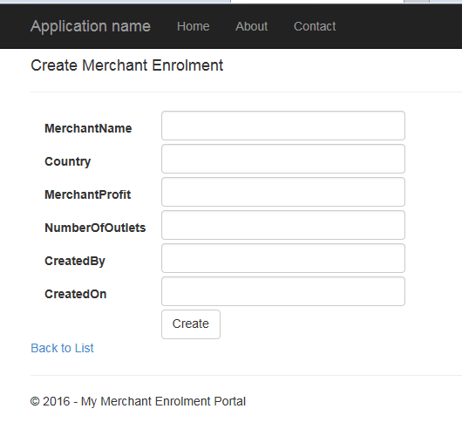

All the required fields.

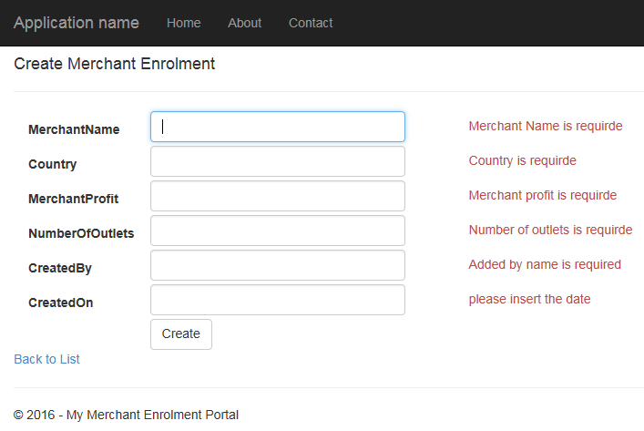

Minimum no of Outlets should be 10.

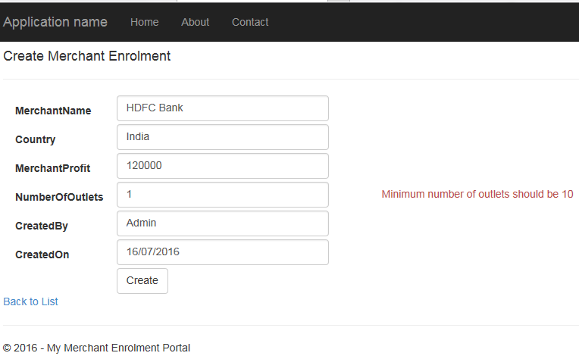

We can edit merchant details

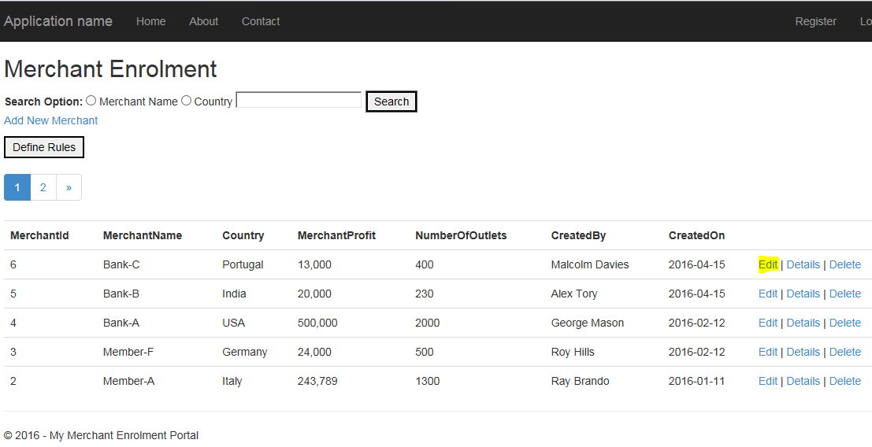

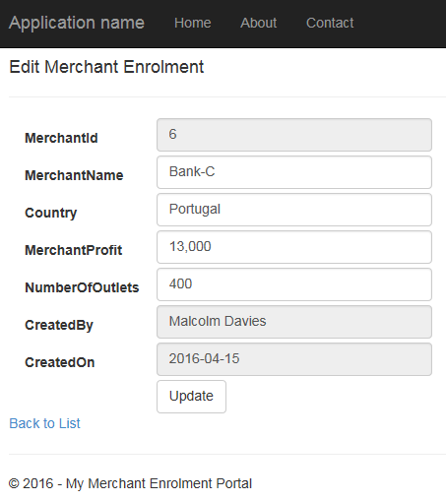

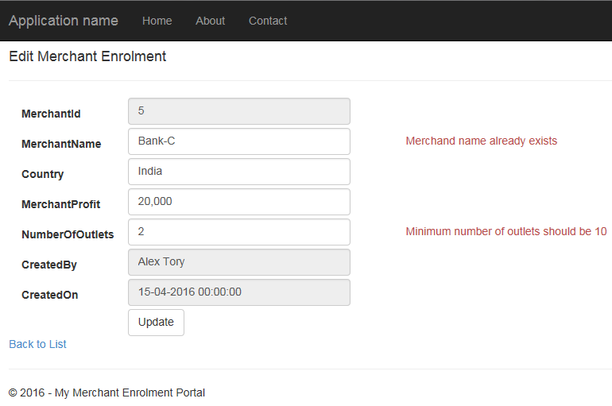

We can define the enrolment rules by clicking on Define Rules

